Healthy Schools act required training
As of July 1, 2016, anyone who uses disinfectants on a school site, including disinfectant wipes, is required to take a Department of Pesticide Regulation-approved training. (SB1405)

What is IPM?
IPM stands for “Integrated Pest Management”. The term is used to describe actions everyone can take to reduce the use of pesticides.
WHAT ARE PESTS?
Anything you don’t want around, like germs, viruses, bacteria, insects, rodents, even weeds.
WHAT CAN YOU DO TO HELP OUT?
1. PREVENT- Clean your areas, remove moisture, food, debris and anything pests need to survive.
2. MONITOR- Stay alert to new pests.
3. COMMUNICATE- Most important! Alert your maintenance and custodian staff of any concerns you have and work together to solve the problem!

ADDITIONAL RESOURCES
Department of Pesticide Regulation School IPM website: ***HSA TRAINING***
www.cdpr.ca.gov/schoolipm/

Work-Related Asthma Prevention Program
1-800-970-6680

Purchase safer cleaning chemicals and disinfectants: www.greenseal.org/certification/gs37_iicleaners.cfm
www.epa.gov/pesticides/regulating/labels/design-dfe-pilot.html

Safer cleaning and disinfecting fact sheets and guidelines: www.informedgreensolutions.org
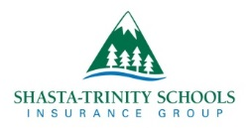
Use and Care of Microfiber Towels

Date of publication

Safe Cleaning

Healthy Children
350 Hartnell, Suite D
Redding, CA 96002
530.221.6444
FAX 530.221.6225

For questions regarding this pamphlet or any safety concerns at your school district please contact the STSIG Loss Prevention Manager:
Kurt Walling
kwalling@stsig.org

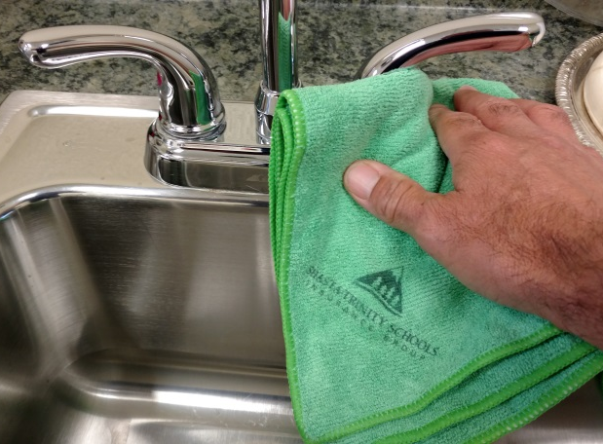

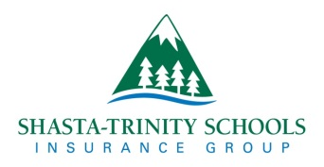

WHAT IS MICROFIBER?

Microfiber cloths contain fibers that are about 1/100th the size of a human hair, so they can trap and remove soils and germs without the need for chemicals. The tiny fibers penetrate cracks that traditional cloths cannot, and they carry an electric charge that attracts dust.

CROSS SECTIONS

Cotton thread and dirt particles

Microfiber thread and dirt particles
(Picks up and holds much more!)
WHY USE MICROFIBER TOWELS?

The use of cleaning chemicals, sanitizers, and disinfectants can cause or trigger asthma and many other health problems.
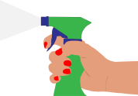
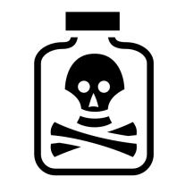
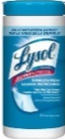

Regular cleaning with microfiber removes up to 99% of germs.
Cleaning with microfiber can result in healthier classrooms without using as many chemical cleaning products.

REMEMBER: Always use the least toxic method to take care of pests. Microfiber towels are a great start to a clean and safe school!

CARE AND CLEANING
When washed properly microfiber can last hundreds of washings!
Follow these simple tips to maximize the life of your microfiber:

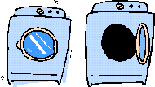
WASHING
- Wash separately
- Don’t mix with terry or cotton towels to avoid lint
- Wash in cold or warm water 105° or less

- Use mild detergent
- No bleach
- No fabric softener- will clog fibers

- Tumble dry low heat, air dry, or place in an extractor
- Avoid placing in hot dryer
- High heat melts fibers making them non-absorbent

DETERGENT


DRYING

